Apache JMeter

Version 1.0
Date 02/11/10

Copyright notice
Copyright © 2010, Cognizione consulting & solutions Pvt Ltd
All rights reserved.

These materials are confidential and proprietary to Cognizione consulting & solutions pvt
ltd/its licensors and no part of these materials should be reproduced, published, transmitted
or distributed in any form or by any means, electronic, mechanical, photocopying, recording or
otherwise, or stored in any information storage or retrieval system of any nature nor should the
materials be disclosed to third parties without the prior express written authorization of
Cognizione consulting & solutions Pvt ltd/its licensors
Revision history

Doc No: | Version no. | Change reference no. | Author | Published date | Sections changed | Description of changes
 | 1.0 |  |  | 02/11/10 |  | Base Document

CONTENTS

Purpose of the document 4
Purpose of the document 4
Scope of the document 4
Desired outcome 4
Targeted recipient 4
Prerequisite 4
Required Software 4
JMeter 5
Installing and Running JMeter 5
Using JMeter for a Simple Test 6
Creating a Thread Group 6
Adding a HTTP request 9
Adding a Listener 13
Running the Test 14
Listeners 16
Multiple HTTP Requests 16
HTTP Request Defaults 16

Figures Used

Figure 1 :- Apache JMeter Interface 5
Figure 2 – Creating a ThreadGroup 6
Figure 3 :- ThreadGroup Panel 7
Figure 4 :- Scheduling option enabled with Scheduler 8
Figure 5 :- ThreadGroup values 9
Figure 6 :- Adding a HTTP Request 10
Figure 7 :- HTTP Request Panel 11
Figure 8 :- Configuring an HTTP Request element. 12
Figure 9 :- Adding a Listener 13
Figure 10 : Listener Panel 14
Figure 11 : Configuring Listener 14
Figure 12 :- Running the Test 15
Figure 13 : - Sample test output 15

Purpose of the document

This document describes the following

- Using Apache JMeter to load test a web application

Scope of the document

This document only explains the process of using Apache JMeter tool to load test a web application. It doesn’t explain the following points

- Different types of testing
- Different strategies on load testing
- Running a web application

Desired outcome

- Load test of a web application using Apache JMeter tool.

Targeted recipient

Developers who are also responsible for performing load testing.

Prerequisite

- Knowledge of testing.
- Knowledge of web application and how to run them.

Required Software

The following Softwares are required for the process.

- Apache JMeter 2.3.4

These are already available under “D:\Softwares\Testing Tools” in CCS7 machine.

JMeter
JMeter is a Java-based tool for load testing client-server applications. Stefano Mazzocchi originally wrote it to test the performance of Apache JServ (the predecessor of Jakarta Tomcat). It has since become a subproject of Jakarta.

Installing and Running JMeter

Installation only requires extracting the binary distribution file, and JMeter is ready for you. In fact the extracted folders are already available under “D:\Softwares\Testing Tools” in CCS7 machine.

Double click the “ApacheJMeter” executable jar file inside the bin folder of the JMeter folder to run JMeter. This will come up with the following interface.

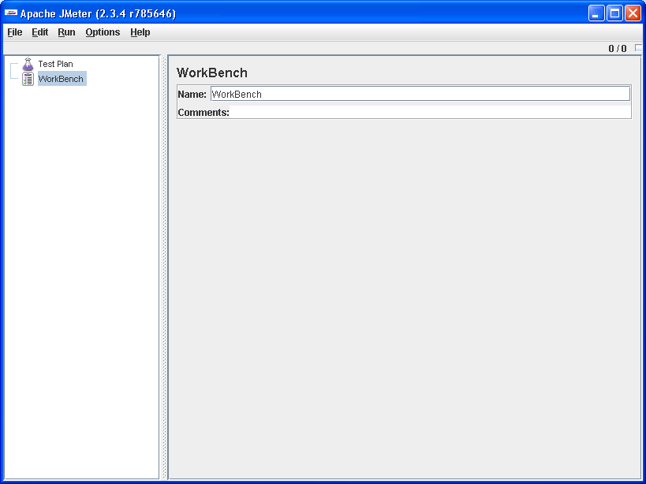

Figure 1 :- Apache JMeter Interface

There are two things to note:

- You should not run JMeter on the same machine running the application to be tested. JMeter may use extensive resources that might affect the other application's performance if they are both run on the same machine.

- Make sure that the testing is affected as little as possible by network traffic.

Using JMeter for a Simple Test
In this test, we will set up a test plan and stress test R+Plus application’s Login Page.

To conduct a test, you must have a test plan. A test plan describes the steps that JMeter will take to perform the testing. A test plan includes elements such as thread groups, logic controllers, sample generating controllers, listeners, timers, assertions, and configuration elements. Don’t worry about these terms as they will be explained on as we go forward.

A test plan must have at least one thread group.

A thread group is the starting point of a test plan, and it can contain all other JMeter elements. A thread group controls the threads that will be created by JMeter to simulate simultaneous users.

Creating a Thread Group

- Right-click the Test Plan element and select Add and then Thread Group. JMeter will create a thread group element under Test Plan element.

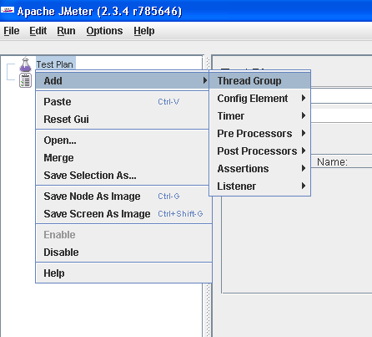

Figure 2 – Creating a ThreadGroup

- Click the Thread Group element, and you will see a screen like the one in Figure
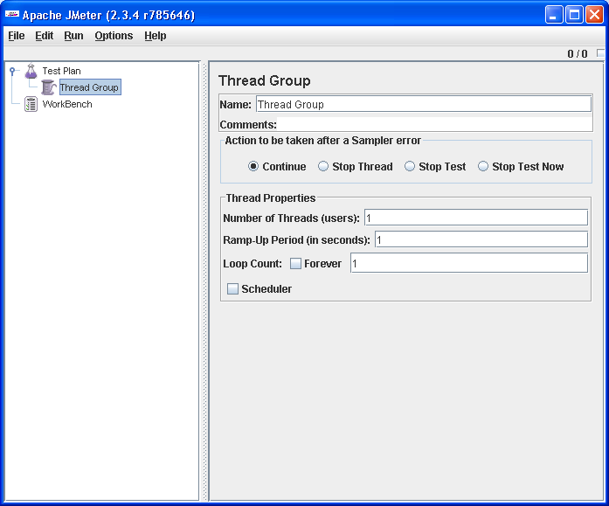
Figure 3 :- ThreadGroup Panel

In this page, you can set the following properties:

Name -- the name of this thread group. You can give a descriptive name to this property.

Number of Threads -- the number of threads created. Each thread represents a single user. Therefore, if you want to simulate a load test with 10 concurrent users, enter 10 as the value for this property.

Ramp-Up Period -- the number of seconds JMeter will take to accelerate to create all of the threads needed. If the number of threads used is 10 and the ramp-up period is 20 seconds, JMeter will take 20 seconds to create those 10 threads, creating one new thread every two seconds. If you want all threads to be created at once, put 0 in this box.

Forever -- if clicked, this option tells JMeter to keep sending requests to the tested application
indefinitely. If disabled, JMeter will repeat the test for the number of times entered in the Loop Count box.

Loop Count --this property value only has an effect if the Forever check box is unchecked. It tells JMeter the number of times it has to repeat the test.

Scheduler – enabling this option lets to schedule the test plan.
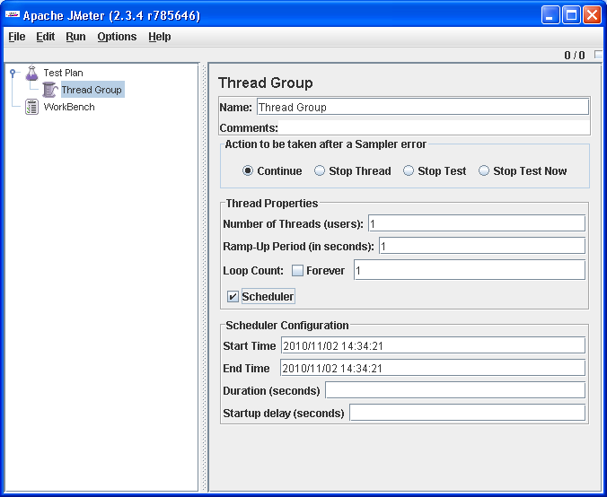
Figure 4 :- Scheduling option enabled with Scheduler

- Fill up the values as shown in the below figure
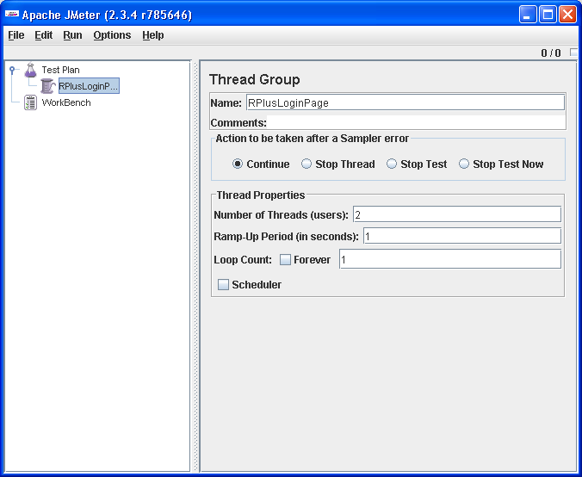

Figure 5 :- ThreadGroup values

Adding a HTTP request

- Right-click the Thread Group element, and select Add, Sampler, and then HTTP Request. An HTTP Request element will be added to the Thread Group element.

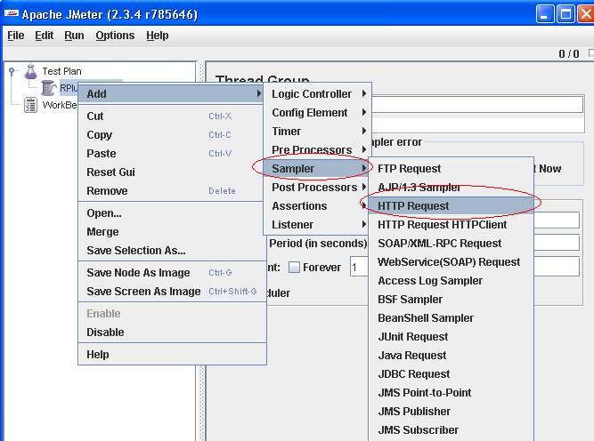

Figure 6 :- Adding a HTTP Request

- Click the HTTP Request element to select it, and you should see a screen similar to Figure 7.
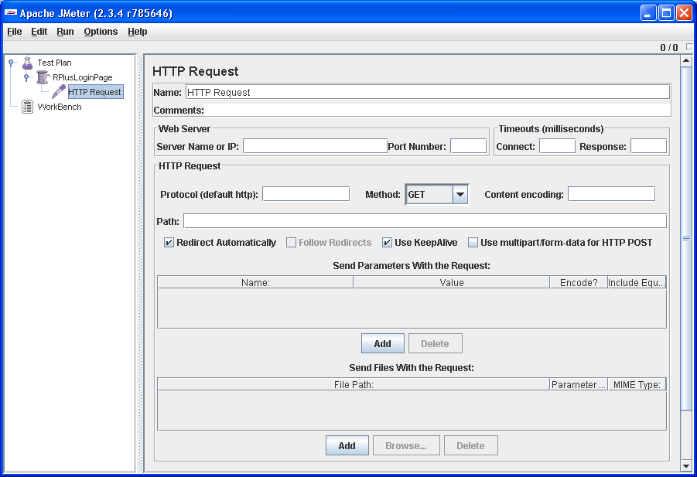

Figure 7 :- HTTP Request Panel

On the HTTP Request screen, you configure the HTTP requests that will be used to "hit" your application.

Here, you can set the following properties.

Name -- the name of this HTTP request. The name should be descriptive; remember that it is common to have multiple HTTP Request elements in a thread group.

Server Name or IP -- the server name or the IP address of the machine running the application being tested.

Port Number -- the port number used by the application. Normally, a Web application runs on port 80.

Protocol -- the protocol used, either HTTP or HTTPS.

Method -- the request method, either GET or POST.

Path -- the path to the resource that will handle this request.

Follow Redirects -- follows redirections sent by the Web application, if any.
Use KeepAlive -- if checked, sends the Connection = Keep-Alive request header. By default, an HTTP 1.1 browser uses Keep-Alive as the value of the Connection header. Therefore, this checkbox should be checked.

Parameters -- the list of parameters sent with this request. Use the Add and Delete buttons to add and remove parameters.

Send a file with a request -- simulate a file upload to the Web application.

- Fill up the values as per the figure below

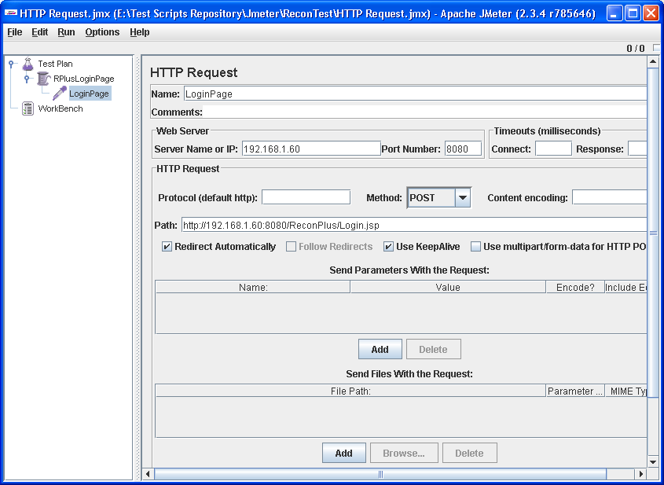

Figure 8 :- Configuring an HTTP Request element.

The last element that we need to add to our test plan is a listener, which in JMeter is the same as a report.

JMeter comes with various reports to choose from. A report can be a table or a graph. For this testing, we will use the easiest report available: a table.

Adding a Listener

- Right-click the Thread Group element (RPlusLoginPage), select Add, and then Listener and View Results in Table.

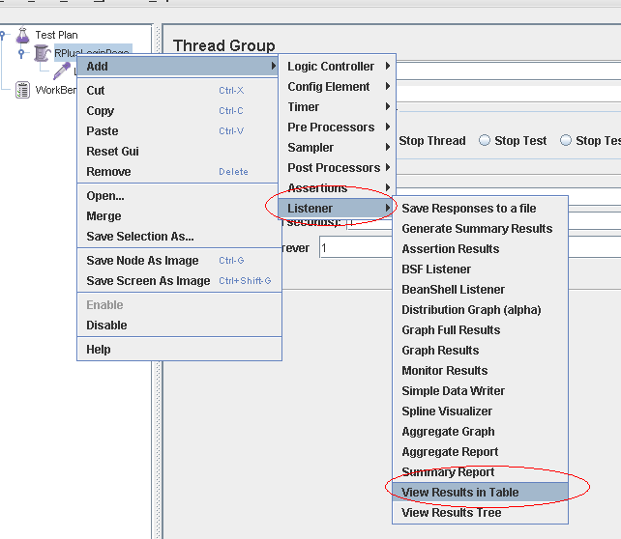

Figure 9 :- Adding a Listener

- This will open up the Listener panel as shown in fig 10

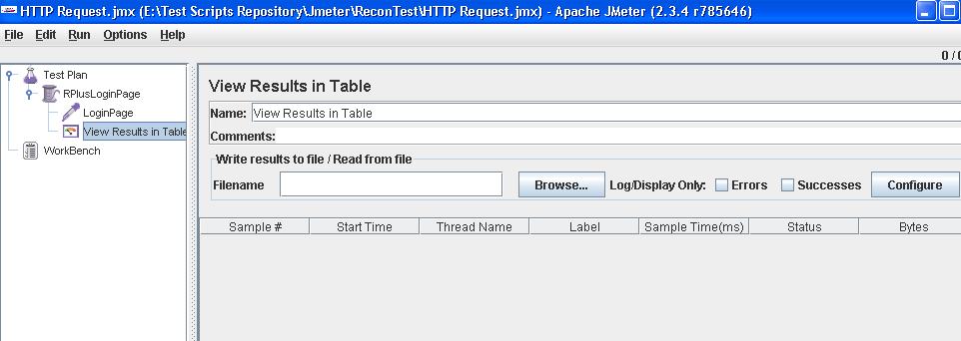

Figure 10 : Listener Panel

- Fill up the values as shown in Fig 11

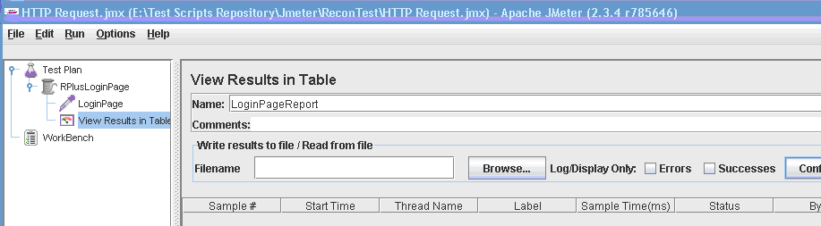

Figure 11 : Configuring Listener

- Save the test plan, from “File→ Save Test Plan As”.

- Additional configuration can be done by clicking the “Configuration” button. Also the output can be written to a file and we can also choose to log only errors or successes.

Now you are ready to run the test plan.

Running the Test

- Click on “Run → Start” , as shown in figure 12.
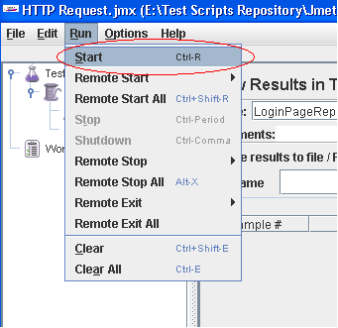

Figure 12 :- Running the Test

A sample output for the above test is shown below. The figures are self explanatory.

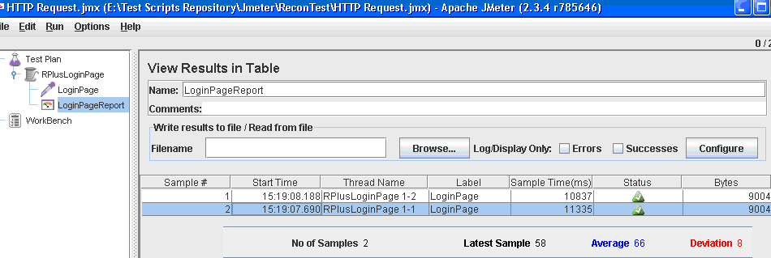

Figure 13 : - Sample test output

Another important figure is the standard deviation(in red , in figure 13), defined as the square root of the total of the deviation of each sample from the average. This figure indicates how stable your Web application is. If the standard deviation is high, some users will experience very good responses while some other users will wait for a longer time. The smaller this value, the better.

While the test plan executes, the small box on the bar right below the menu bar will turn green. For a test that does not run indefinitely, JMeter will automatically stop the test plan after it's finished.

For a test that goes on indefinitely, you must intervene to stop the test. Do this by selecting Stop from the Run menu.

After conducting a simple test, it is very easy to do more complex tests. For load testing Web applications, increase the number of threads and the loop counts gradually and see how your applications cope with the loads.
The following sections of this article briefly tackle some other important aspects of load-testing Web applications with JMeter. Interested readers can refer to literature available in Internet for further details.

Listeners
JMeter comes with a number of listeners or reports. In the previous test, we used a table to display the test
results. If this is not suitable for you, you can choose one or more of the other listeners for a thread group.

Multiple HTTP Requests
A real application has multiple resources, both static and dynamic. Chances are, you want to see the performance of these resources. JMeter makes it easy to employ multiple HTTP requests. Just add any number of HTTP Request elements and configure them, as in the previous test. If you have multiple HTTP Request elements, you might want to use a HTTP Request Defaults element, described in the following section.

HTTP Request Defaults
The HTTP Request Defaults element specifies the default values of existing HTTP Request elements within the same thread group. The HTTP Request Defaults element is especially useful because most, if not all, HTTP Request elements normally have the same server and port.

